The Feathers and Flights Journey

North-Central Cruise / Itinerary C / 6 Days – 5 Nights

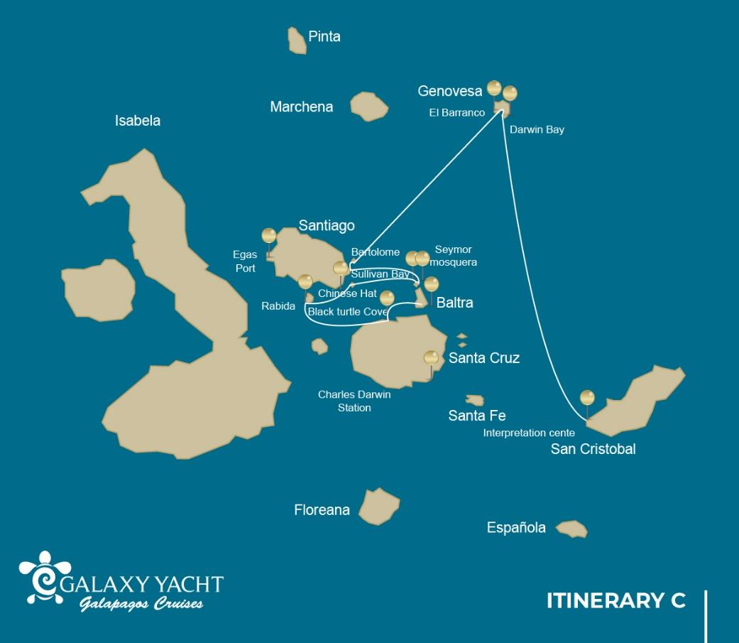

 |  |  |  | HIKING | SNORKEL | PANGA RIDE | PADDLE  BOARD | KAYAK
6 DAYS "C" | THURSDAY | PM | Santa Cruz: Black Turtle Cove |  |  | •
 | FRIDAY | AM | Rabida: Rabida | • | • | • | • | •
 |  | PM | Chinese Hat | • | • | • | • | •
 | SATURDAY | AM | Seymour: Seymour | • | • | •
 |  | PM | Mosquera: Mosquera | • | •
 | SUNDAY | AM | Santiago: Sullivan Bay | • | •
 |  | PM | Bartolome: Bartolome | • | • | •
 | MONDAY | AM | Genovesa: El Barranco | • | • | • | • | •
 |  | PM | Genovesa: Darwin Bay | • | • | • | • | •
 | TUESDAY | AM | San Cristobal: Interpretation Center | •

Day 1 – Thursday

AM: BALTRA AIRPORT - BEGINNING A NEW ADVENTURE
Departure to the Galapagos Islands, arrive at Baltra airport, where a National Park-certified naturalist guide will warmly welcome you to this biodiversity-rich paradise. Your exciting journey in the footsteps of Darwin is about to start!
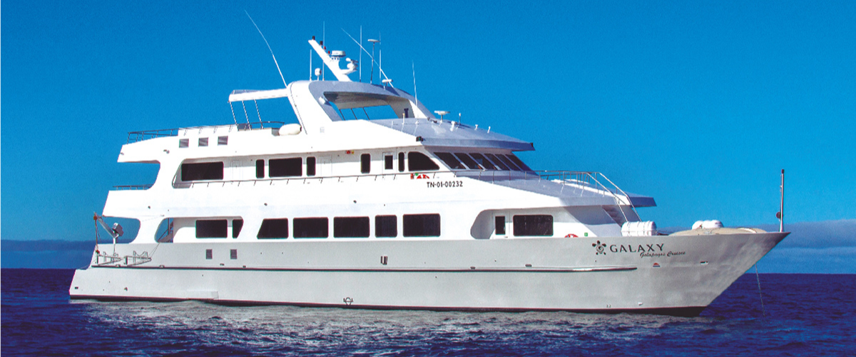

PM: BLACK TURTLE COVE - A SANCTUARY OF MARINE LIFE
At Black Turtle Cove, named for the abundant green sea turtles, locally known as "Tortugas Negras," you're in for a delightful boat tour onboard the dinghies. Your adventure here is a peaceful exploration of shallow channels, small coves, and beautiful mangrove forests surrounding the area.
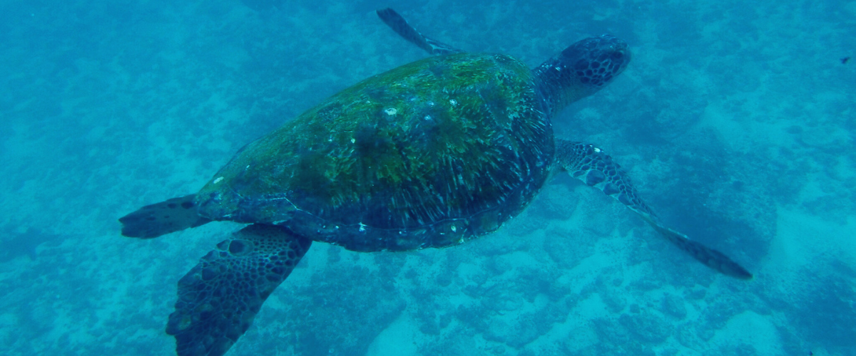

Reef sharks, sea turtles, and several species of rays inhabit this tranquil sanctuary, which is considered a crucial mating area for turtles and a nursery for various shark species. Look out for herons, pelicans, and boobies who make this their feeding ground, preying on schools of anchovies. There's no landing at Black Turtle Cove. Still, the rich biodiversity experienced from the boat more than makes up for it, offering up-close encounters with the wonderful marine life of the Galapagos.
Highlights: White-tipped and black-tipped reef sharks, green sea turtles, rays, herons, blue-footed boobies, and mangroves.
Meals | L / D
Level | 1
Activities | Panga Ride

Day 2 – Friday

AM: RABIDA - A REDDISH HAVEN
Rabida Island, recognized for its unique reddish lava rocks enriched with iron, has a distinct appearance in the Galapagos. The beach's unusual red hue reflects this characteristic, serving as a home for a small sea lion colony. If you're lucky, you'll discover a small saltwater lagoon inhabited by ducks, stilts, and flamingoes.
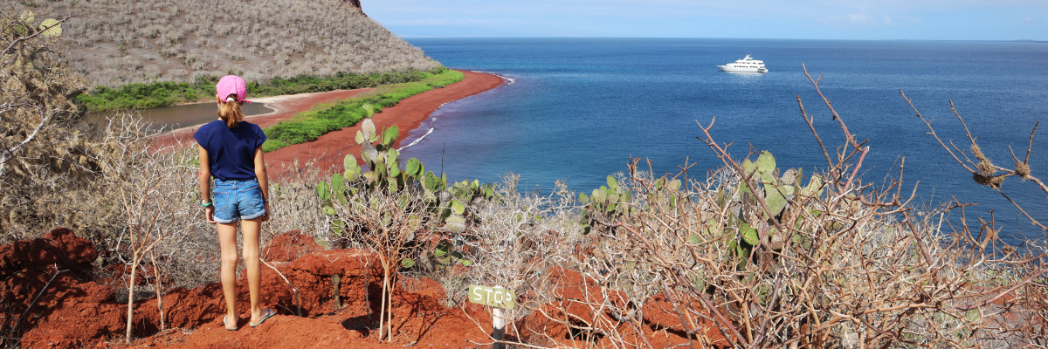
The trail invites you inland, offering spectacular beach and lagoon views. Keep an eye out for Darwin finches, flycatchers, and mockingbirds. Along the coastline cliffs, you can observe Nazca & blue-footed boobies, brown noddies, herons, and the two species of sea lions: the Galapagos and fur seals.
Snorkeling Experience: Embark on a snorkeling adventure from the beach and explore a protected rocky area brimming with fish, sea lions, and reef sharks. The vertical walls are a natural canvas showcasing an impressive variety of small invertebrates.
Highlights: Red-sand beach, Galapagos sea lions, Galapagos hawks, flycatchers, Darwin finches, Galapagos mockingbirds, ducks, flamingoes.
Trail | 2 km / 1,2 mi
Level | 1
Activities | Wet landing and hiking

PM: CHINESE HAT - A PERFECT VOLCANIC CONE
Chinese Hat, named for its perfectly symmetrical volcanic cone shape, is a small islet separated from Santiago by a narrow channel, forming one of the most beautiful bays in the Galapagos. The contrast of the blue-turquoise water, coral sand beaches, and dark lava rocks add a real tropical flair to the area, making the sight of penguins resting on the rocks even more astonishing. The trail guides you along the shore, leading you through a small sea lion colony.
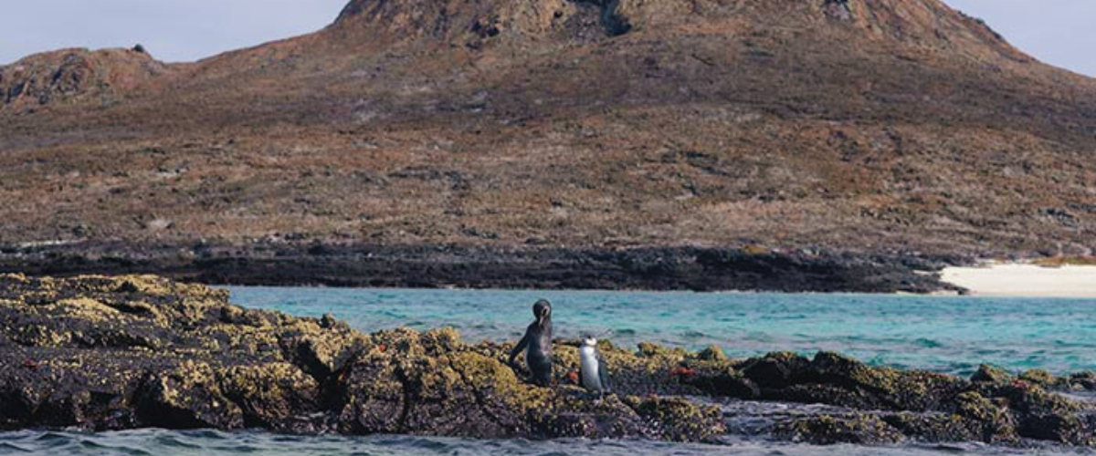
Snorkeling Experience: As you swim in these vibrant waters, the incredible colors of the fish and the sleek shapes of reef sharks will captivate you. It's common to witness a penguin darting through the water in pursuit of anchovies, resembling a small, agile torpedo.
Highlights: Galapagos sea lions, Galapagos penguins, lava tubes, oystercatchers, Galapagos hawks.
Meals | B / L / D
Trail | 1,3 km / 0,8 mi
Level | 1
Activities | Wet landing and hiking

Day 3 – Saturday

AM: SEYMOUR - A BIRDWATCHER'S PARADISE
Seymour Island is a paradise for bird lovers, with large colonies of magnificent and great frigatebirds showcasing their impressive red gular pouches to attract females. Blue-footed boobies nest on the ground and perform their famous courtship dance in the open areas. At the same time, swallow-tailed gulls can often be seen perched on the cliff edges. Land iguanas, their numbers restored through a successful conservation program, are a common sight inland, while their marine cousins bask in the rocks by the sea, not far from playful sea lions that frequently body surf in the waves.
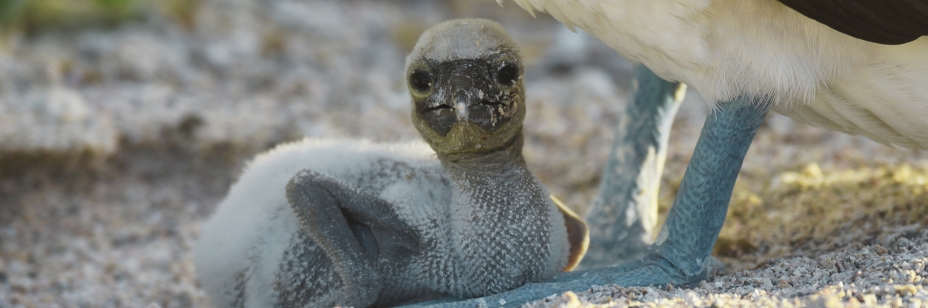
Snorkeling experience: Don't miss the opportunity to explore the underwater world here; the site offers tremendous diversity and an abundance of sea creatures such as fish, sea lions, sharks, eels, turtles, rays, and many more.
Highlights: Galapagos sea lions, blue-footed boobies, magnificent & great frigatebirds, land & marine iguanas, swallow-tailed gulls, shearwaters, and Darwin finches.
Trail | 1,4 km / 0,8 mi
Level | 1
Activities | Dry landing and hiking

PM: MOSQUERA - A SEA LION PLAYGROUND
Mosquera, mostly a barren sandbar with some rocky areas and scattered salt-resistant plants, offers an incredible experience of watching playful sea lion pups surfing the waves and enjoying the tide pools. While strolling along the beach, keep an eye out for the endemic lava gulls often seen flying overhead in search of food.
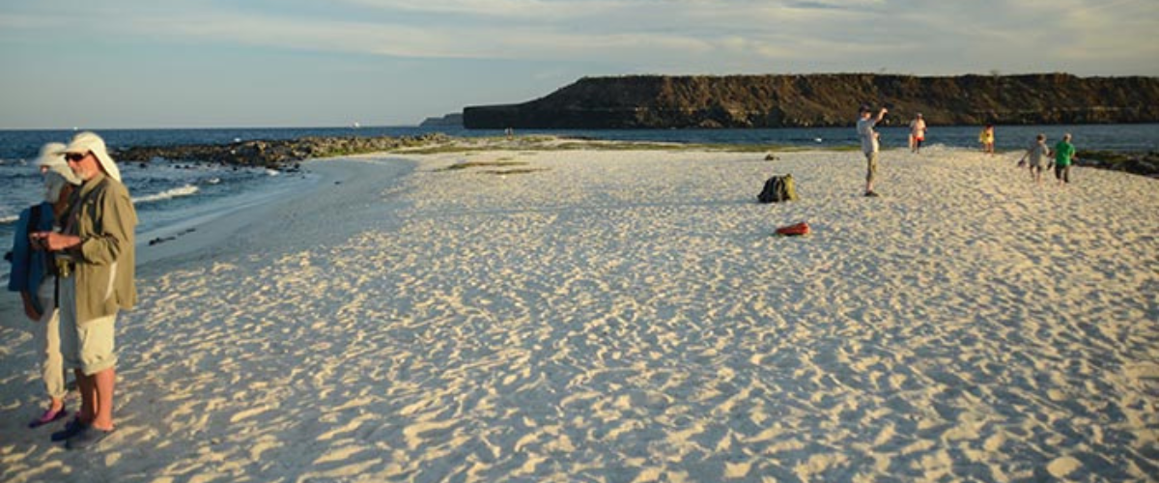
Snorkeling Experience: Depending on the waves, you can snorkel at the northern tip of the island or one of the small beaches on the sheltered side, offering another chance to observe the vibrant marine life of the Galapagos.
Highlights: Galapagos sea lions, lava gulls, oystercatchers, shorebirds.

Meals | B / L / D
Trail on the sandy area | 0,6 km / 0,4 mi
Level | 1
Activities | Wet landing and hiking

Day 4 – Sunday

AM: SULLIVAN BAY - A VOLCANIC WONDERLAND
Walking through Sullivan Bay offers an extraordinary journey into the volcanic origins of the Galapagos Islands. Your hike will take you across a perfectly preserved Pahoehoe lava flow, providing endless opportunities to observe the delicate textures of this rare type of lava. While the landscape may appear barren and lifeless at first, a closer look reveals resilient pioneer plants, scurrying lava lizards, and small birds. Along the shore, penguins, pelicans, and oystercatchers add a touch of life to the stark environment.
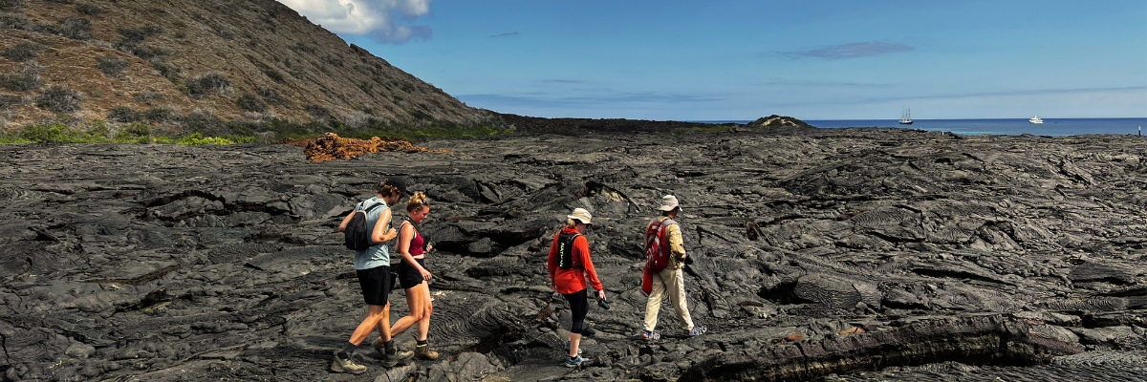
Snorkeling Experience: Following the hike, you can swim or snorkel from a coral sand beach or the dinghies. The underwater world here starkly contrasts the sparse land, teeming with schools of fish, Galapagos penguins, reef sharks, turtles, and rays.
Highlights: Pahoehoe lava, Galapagos penguins, oystercatchers, Galapagos hawks.
Trail | 2,2 km / 1,4 mi
Level | 3
Activities | Dry landing and hiking

PM: BARTOLOME - ICONIC VIEWS AND PENGUIN ENCOUNTERS
Bartolome Island is one of the most iconic places in the Galapagos, renowned for its accessible penguin population and the beautiful Pinnacle Rock. The beach nearby the rock is painted with peach-colored sand, adding to the surreal beauty of the landscape. A hike to the island's summit will offer you panoramic views of lunar-like landscapes dotted with volcanic cones, numerous islands, Sullivan Bay, and, of course, the towering Pinnacle Rock.
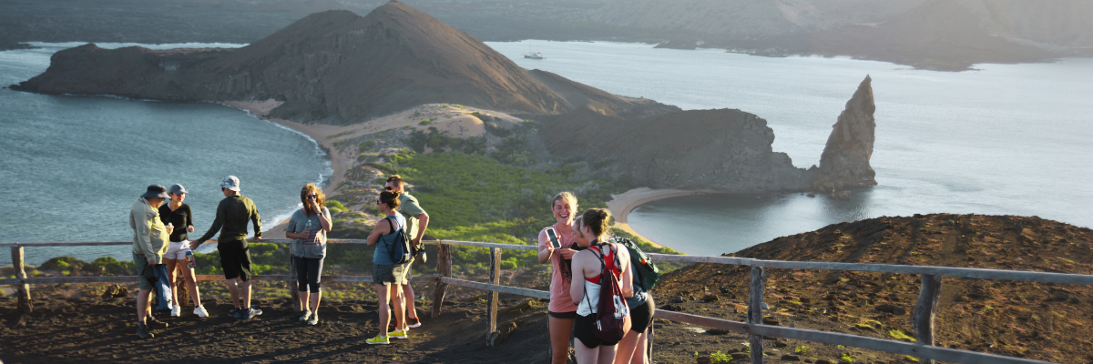
Snorkeling Experience: Following the hike, you have the option to swim or snorkel from the beach. This location boasts a well-deserved reputation as one of the best snorkeling spots in the Galapagos, with its clear, calm water and diverse underwater life. This includes penguins, which are surprisingly easy to spot, along with many colorful fish, invertebrates, playful sea lions, turtles, rays, and reef sharks.
Highlights: Galapagos penguins, volcanic landscapes, Pinnacle rock, blue-footed boobies, herons, sea lions, and sharks.
Meals | B / L / D
Trail | 1,5 km / 0,9 mi
Level | 2
Activities | Dry landing and hiking

Day 5 – Monday
The itinerary of Genovesa, Darwin Bay, and El Barranco, established on this day, has been changed on September 20, 2023, by the Galapagos National Park Directorate (GNPD) due to a Contingency Plan for the Conservation of Species on this island. In its place, visits will be made to the neighboring islands based on the authorization of the Galapagos National Park.
This itinerary will return to normal when the GNPD considers it optimal for the reception of passengers again on Genovesa Island.

AM: EL BARRANCO - BIRDWATCHER'S PARADISE
Located in the southern part of Darwin Bay on Genovesa Island, El Barranco is blessed with cliffs facing the sea made from very fragile, fractured lava. This creates an ideal nesting environment for storm petrels, attracting a significant population of short-eared owls. The trail is dotted with red-footed and Nazca boobies. At the same time, the base of the cliffs provides restful, shaded areas for Galapagos fur seals and numerous seabirds.
Snorkeling Experience: Snorkeling alongside these cliffs is an exhilarating experience, teeming with diverse fish and providing great chances to see sharks, rays, and playful sea lions.
Highlights: Nesting great frigatebirds, red-footed & Nazca boobies, Galapagos sea lions, Galapagos fur seals, lava & swallow-tailed gulls, yellow-crown night herons, Genovesa ground finch, Genovesa cactus finch, Galapagos mockingbirds.
Trail | 1,2 km / 0,7 mi
Level | 3
Activities | Wet landing and hiking

PM: SAN CRISTOBAL ISLAND: HIGHLANDS
The Highlands of San Cristobal are one of the Galápagos Islands' most verdant and breathtaking landscapes. Its name, evoking elevations and lush terrains, is fitting: the area is a sanctuary of giant tortoises and offers a mosaic of biodiversity. This green haven is a must-visit for those longing for a deeper connection with nature. Here, the essence of the island truly comes alive.

Exploration: In the highlands, trek through mist-covered forests and perhaps witness the graceful movement of a giant tortoise in its natural habitat.

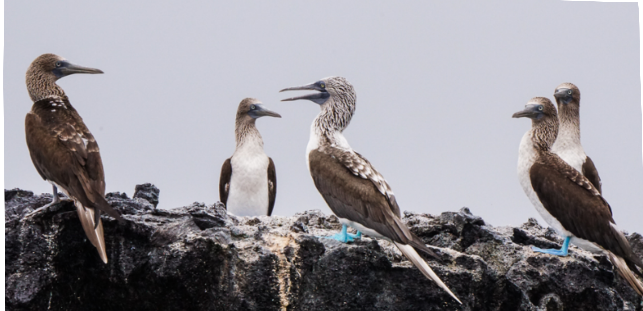
Highlights: Galapagos Giant Tortoises
Meals | B / L / D
Level | 3
Activities | Wet landing and hiking

Day 6 – Tuesday

AM: INTERPRETATION CENTER - A JOURNEY THROUGH HISTORY
Situated on the outskirts of Puerto Baquerizo, the Interpretation Center serves as a rich repository of the history of human presence in the Galapagos Islands. Its exhibitions chronicle the stories of early Spanish explorers up to the present day, highlighting prominent visitors such as Charles Darwin. The displays at this center illustrate the challenges and perils faced by the first settlers as they endeavored to survive in the rugged Galapagos environment.
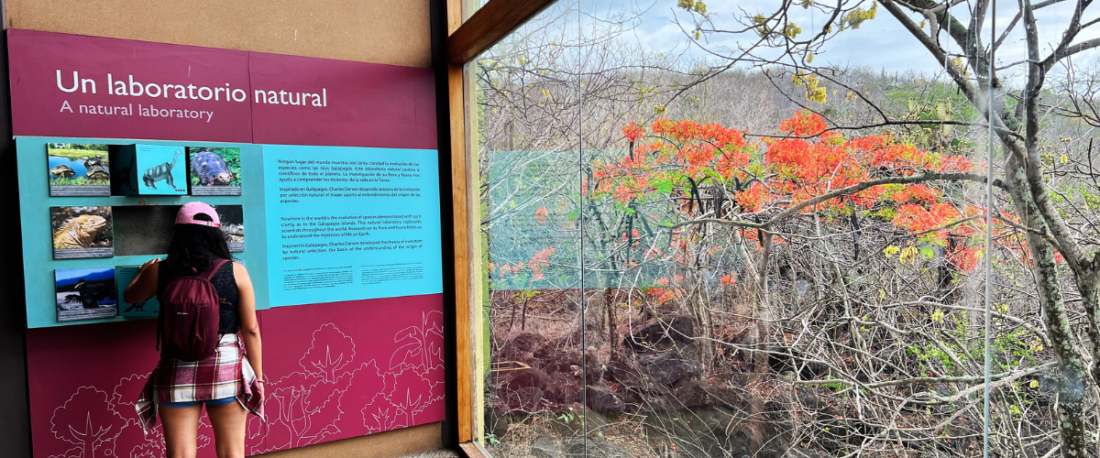
Following your visit to the Interpretation Center, you will be transferred to the airport for your flight back to continental Ecuador. This marks the end of your Galapagos journey, leaving you with memories of incredible wildlife and landscapes that will last a lifetime. Safe travels!
Meals | B / L / D
Trail | 2,2 km / 1,4 mi

Glossary

Meals | Breakfast | B
 | Lunch | L
 | Dinner | D
Hiking Effort | Level 1 | Easy
 | Level 2 | Moderate
 | Level 3 | Hard

