The Vibrant Wild West Journey

Itinerary B / Western Cruise / 6 Days – 5 Nights

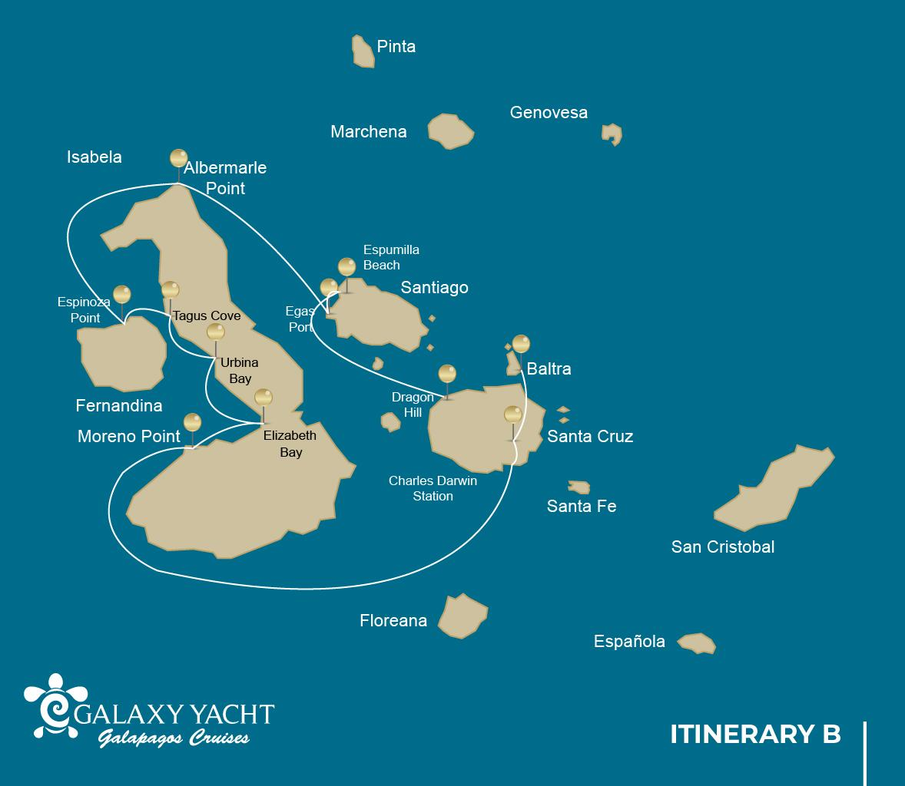

 |  |  |  | HIKING | SNORKEL | PANGA RIDE | PADDLE  BOARD | KAYAK
6 DAYS "B" | SATURDAY | PM | Santa Cruz: Highlands | •
 | SUNDAY | AM | Isabela: Moreno Point | • | • | •
 |  | PM | Isabela: Elizabeth Bay |  |  | •
 | MONDAY | AM | Isabela: Urbina Bay | • | •
 |  | PM | Isabela: Tagus Cove | • | • | • | • | •
 | TUESDAY | AM | Fernandina: Espinoza Point | • | •
 |  | PM | Isabela: Albermarle Point | • | • | •
 | WEDNESDAY | AM | Santiago: Egas Port | • | •
 |  | PM | Santiago: Espumilla Beach/Caleta Bucanero | • | • | • | • | •
 | THURSDAY | AM | Santa Cruz: Dragon Hill | • | •

Day 1 – Saturday

AM: TAKEOFF TO BALTRA AIRPORT
Embark on an unforgettable adventure to the Galapagos Islands, starting with your arrival at Baltra airport. Our expert naturalist guide from the National Park will eagerly await your arrival to introduce you to the wonders ahead.
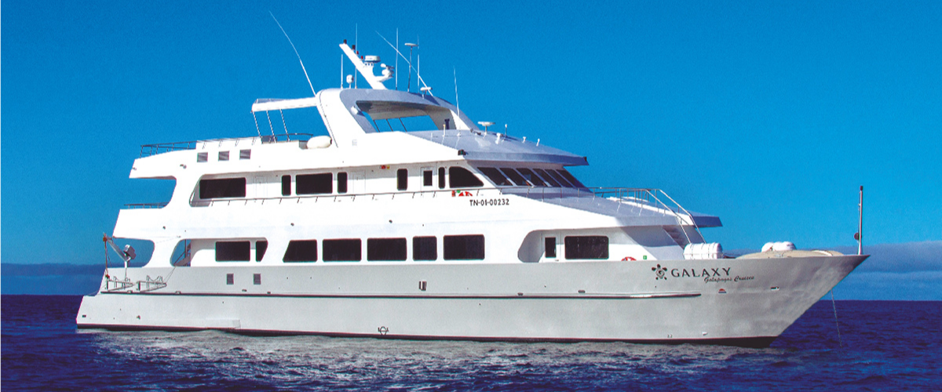

PM: EXPLORING THE HIGHLANDS
Whether you're commencing your exploration from Baltra or Puerto Ayora, a comfortable bus ride will usher you into the verdant embrace of the highlands. En route, we'll pause at a reserve, where you'll step into lush highland forests to seek out Galapagos Giant tortoises in their natural habitat. Witness these gentle titans - some weighing more than 300 kg / 600 pounds - as they graze and recline in tranquil freshwater ponds. These highlands are also a sanctuary for many bird species seldom found in the lowlands, such as finches (tree, woodpecker, and vegetarian), flycatchers, and numerous waterbirds. Depending on your itinerary, you'll also visit a lava tunnel. Here, you'll delve into the fascinating geological history of the Galapagos, understanding how ancient volcanic eruptions crafted these extraordinary formations.
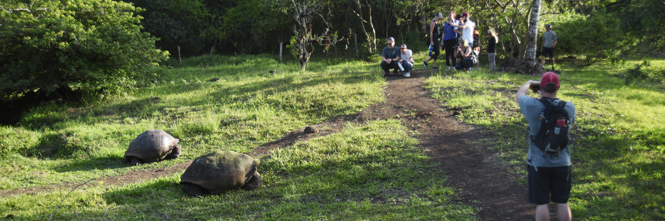
Highlights: Giant tortoises, Darwin finches, barn owls, white-cheeked pintails, Galapagos flycatchers, Lava tunnels.
Meals | Lunch (L), Dinner (D)
Trail | 1 - 1,5 km / 0,6 – 0,9 mi
Level | 1
Activities | Dry landing and hiking

Day 2 – Sunday

AM: THE LAVA WILDERNESS OF MORENO POINT
Begin your day at the seemingly barren yet enchanting landscape of Moreno Point, a vast tableau of lava fields that unfolds into a tapestry of life. As you venture inland, discover brackish lagoons acting as life's oasis, teeming with flamingos, gallinules, ducks, and herons. Along the coastline, keep an eye out for the playful penguins, marine iguanas, flightless cormorants, blue-footed boobies, sea lions, oystercatchers, and a chorus of other shorebirds.
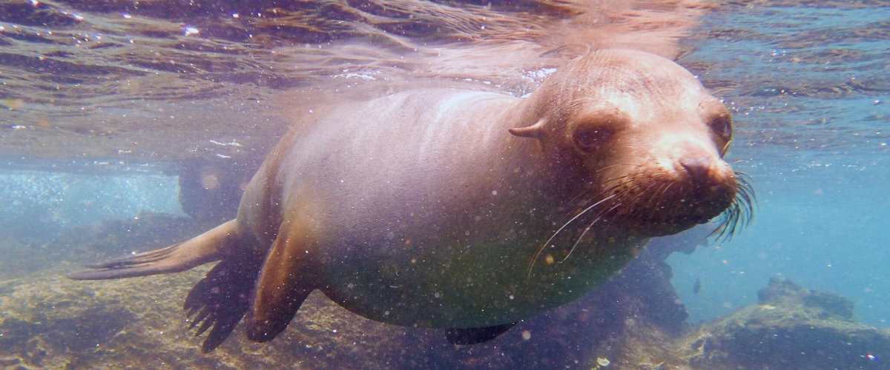
Snorkeling Experience: Submerge yourself in the clear waters for a closer look at sea turtles, cormorants, and an array of fish species. You might even spot the elusive sea horse in the lengthy seaweeds if you gaze carefully.
Highlights: American flamingoes, ducks, gallinules, penguins, cormorants, marine iguanas, sea lions, Galapagos mockingbirds, and Darwin finches.
Trail | 1,6 km / 1 mi
Level | 3
Activities | Dry landing and hiking

PM: MANGROVE HAVEN OF ELIZABETH BAY
As the afternoon unfolds, we explore the beautiful Elizabeth Bay, a tranquil refuge encircled by towering mangroves and desolate lava fields. Devoid of any trails, we'll navigate the area via a dinghy, exploring the intricate network of channels, pools, and coves bustling with marine life. This site is one of the prime locations to observe the rare Galapagos penguins, which count only around 3,000 in total population across the islands. The region is also a nesting ground for flightless cormorants, while blue-footed boobies and pelicans often fish in these shallow, nutrient-rich waters. Look for the graceful rays and sea turtles that abound in this location.
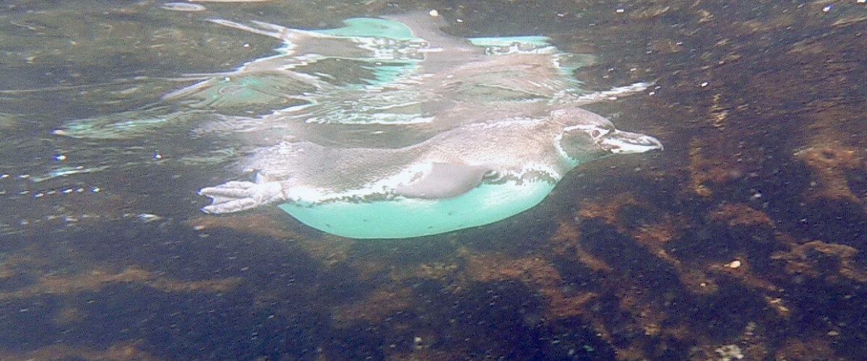
Highlights: Galapagos hawks, sea turtles, rays, Galapagos penguins, flightless cormorants, and herons.
Meals | Breakfast (B), Lunch (L), Dinner (D)
Level | 1
Activities | Panga Ride

Day 3 – Monday

AM: URBINA BAY'S DRAMATIC SEASCAPE
Our journey starts at Urbina Bay, a unique location known for a dramatic geological event in the 1950s. A significant uplift pushed a large coastal area upwards, revealing hectares of previously submerged land. Discover small shells and corals along the trail, a testament to the region's underwater past. This path also provides a chance to see land iguanas and, during certain seasons, giant tortoises. Galapagos hawks are often spotted in the area, flying or perched on trees.
Snorkeling Experience: Dive into the clear waters from the beach to swim alongside sea turtles, cormorants, and penguins. An array of fish also populates the waters here, adding to the vibrant undersea life.
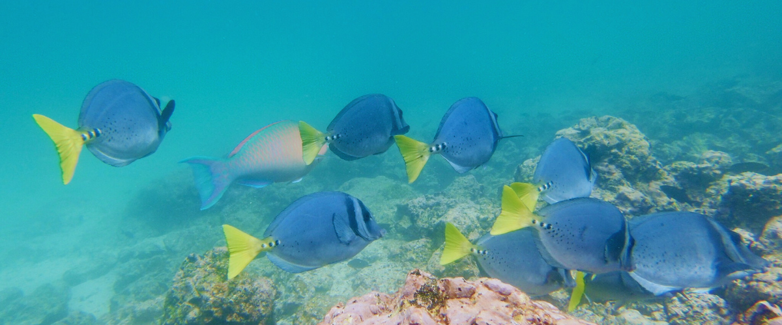
Highlights: Galapagos hawks, land iguanas, Galapagos hawks, Galapagos mockingbirds, Darwin finches, and flycatchers.
Short Trail | 1,2 km / 0,7 mi
Long Trail | 3 km / 1,8 mi
Level | 1
Activities | Wet landing and hiking

PM: TAGUS COVE, DARWIN'S STOMPING GROUNDS
In the afternoon, we visit the historical Tagus Cove, a site Charles Darwin once explored during his travels around the Galapagos islands. Traverse the arid Palo Santo forests, where Darwin finches and mockingbirds make their home, and take in the panoramic views of Darwin’s Lake and the towering volcanoes of northern Isabela.
A boat tour along the shore offers chances to observe penguins, cormorants, marine iguanas, and the rare Galapagos martin - an endemic, petite bird considered one of the most endangered species on the island.

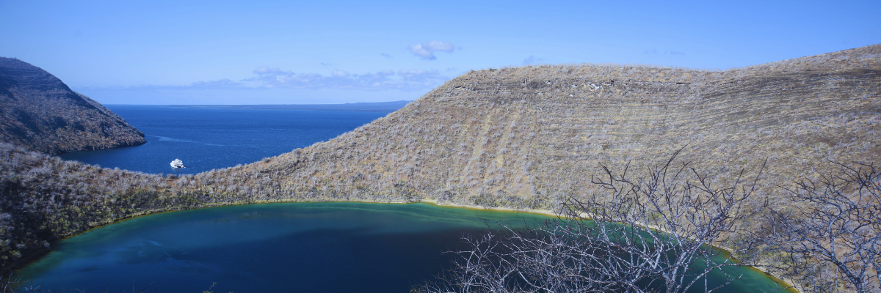
Snorkeling Experience: The nutrient-rich waters around Tagus Cove draw in sea turtles, a rich diversity of fish species, and penguins feasting on large schools of anchovies. Watching cormorants dart underwater as they chase fish through the reef is a common sight.
Highlights: Galapagos hawks, marine iguanas, flightless cormorants, herons, penguins, sea turtles, and sea stars.

Meals | B / L / D
Trail | 2,6 km / 1,6 mi
Level | 3
Activities | Dry landing and hiking

Day 4 – Tuesday

AM: ESPINOZA POINT, VOLCANIC WONDERLAND
Begin your day at Espinoza Point, located at the base of an imposing volcano - the most active in the Galapagos islands. This site, one of the crown jewels of the Galapagos National Park, presents a unique spectacle right from the moment you step ashore. Hundreds of marine iguanas, forming the largest colony of the species, greet you upon arrival. Sea lions lounge on the beaches, their pups playfully exploring the tide pools. Along the shore, catch sight of flightless cormorants, a species confined to the western areas of the archipelago. Blessed with cold, plankton-rich waters, Punta Espinosa is a sanctuary for diverse species, including herons, pelicans, oystercatchers, sea turtles, shorebirds, and more. Also, keep an eye on the mangroves where Galapagos hawks often perch, scanning for prey.
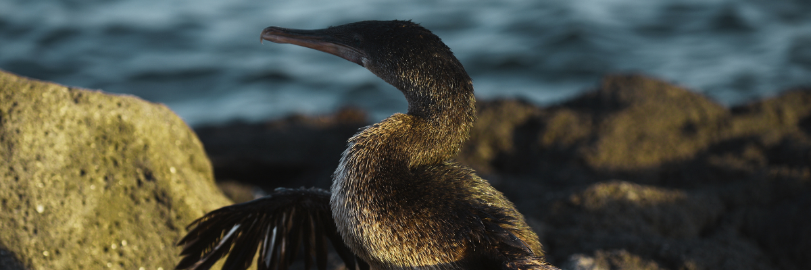
Snorkeling Experience: The nutrient-dense waters around Punta Espinosa attract a myriad of fish and sea turtles. The abundant seaweed makes this spot an ideal location to watch marine iguanas feed underwater. Following a cormorant underwater as it chases fish through the reef will undoubtedly be one of the most incredible snorkeling experiences you'll have on your trip.
Highlights: Galapagos hawks, marine iguanas, flightless cormorants, penguins, sea turtles, sea lions, herons, oystercatchers, shorebirds, and sally light-foot crabs.
Trail | 1,6 km / 1 mi
Level | 2
Activities | Dry landing and hiking

PM: ALBEMARLE POINT, WILDLIFE MEETS HISTORY
In the afternoon, visit Albemarle Point, where wildlife and history intersect. During World War II, the Americans constructed a radar base here to detect the presence of Japanese warships approaching the Galapagos. The remains of the radar can still be seen today. Despite being barren and surrounded by infinite lava fields, the coast is home to some of the largest marine iguanas on the islands, Galapagos penguins, flightless cormorants, and shorebirds.
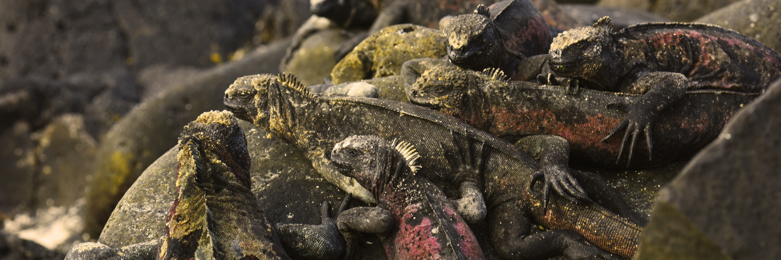
Snorkeling Experience: A couple of sheltered coves here provide excellent opportunities for snorkeling, offering views of cormorants, penguins, and various fish species.
Highlights: Marine iguanas, flightless cormorants, penguins, sea turtles, shorebirds, sally light-foot crabs.

Meals | B / L / D
Trail | 1 km / 0,6 mi
Level | 1
Activities | Dry landing and hiking

Day 5 – Wednesday

AM: EGAS PORT, THE WILD FRONTIER
Despite its misleading name, there isn't a traditional "port" at Puerto Egas, yet some remnants of past attempts to colonize the island during the 1960s can still be seen. The trail here follows the coastline, an area rich in wildlife. You will see marine iguanas basking in the sun everywhere you turn, along with Galapagos sea lions, herons, oystercatchers, and many shorebirds. Towards the trail’s end, you'll encounter "the grottos,” home to a small colony of the elusive endemic Galapagos fur seal, much more challenging to spot than its cousin. As recently as 2019, land iguanas were reintroduced to the area, so keep an eye out for these impressive reptiles, which had been extinct from Santiago for over a century.
Snorkeling Experience: A snorkeling session from the beach will lead you to an area of rocky bottoms, excellent for observing fish, turtles, and reef sharks. Sea lions often frequent this area and are typically open to interacting with divers.
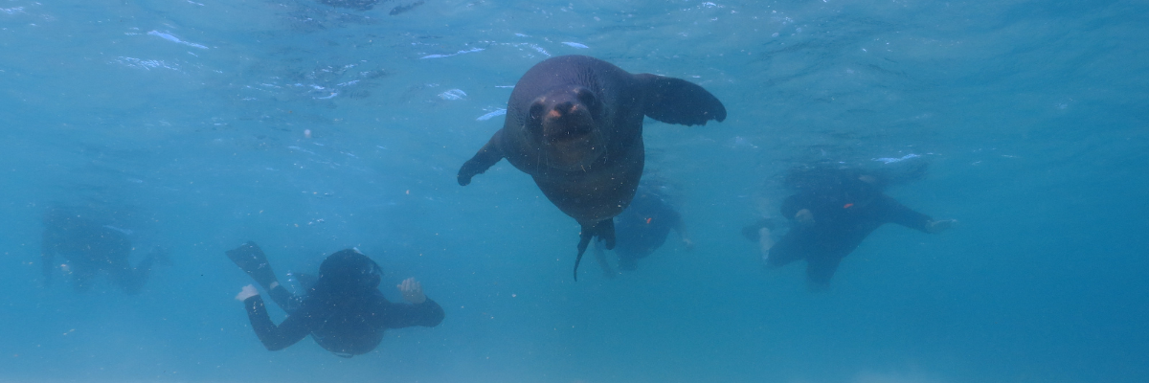
Highlights: Galapagos sea lions, Galapagos fur seals, oystercatchers, marine & land iguanas, Galapagos hawks, herons, shorebirds, Darwin finches, Galapagos doves.
Trail | 2,3 km / 1,4 mi
Level | 1
Activities | Wet landing and hiking

PM: ESPUMILLA BEACH / BUCCANEER COVE, PIRATES' SANCTUARY
Espumilla Beach, located on the northern coast of Santiago, is a stunning 1km (0.6 mi) long expanse of rusty-brown sand. The beach is surrounded by large mangrove trees and a fascinating native dry forest, which houses Galapagos hawks and a wide variety of finches, mockingbirds, and doves. Don't forget to check the salt pan; it could be home to flamingoes and ducks during the rainy season. Buccaneer Cove, named for its use by pirates and buccaneers during the 17th and 18th centuries as a hiding place and source of freshwater and tortoises, is an incredibly scenic site with beautiful cliffs and interesting rock formations. Although there's no trail here, you will take a dinghy ride to observe the wildlife from the small boats.
Snorkeling Experience: In a sheltered bay, snorkel among underwater wildlife, including large schools of fish (angelfish, puffers, parrotfish, snappers, grunts...), reef sharks, sea lions, and sea turtles.
Highlights: Boobies, herons, Galapagos fur seals, swallow-tailed gulls, Galapagos hawks.

Meals | B / L / D
Level | 1
Activities | Wet landing and hiking

Day 6 – Thursday

AM: DRAGON HILL, THE REBIRTH OF A SPECIES
Located on the northern coast of Santa Cruz, Dragon Hill is aptly named after the land iguanas that make their home in this area. This is the only spot on the entire island of Santa Cruz where you can observe these large reptiles. Thanks to a highly successful breeding program, this land iguana population, which was on the brink of extinction during the '70s and '80s, has bounced back remarkably. Apart from iguanas, flamingos, ducks, stilts, sandpipers, and other shorebirds frequently visit a small saltwater lagoon.
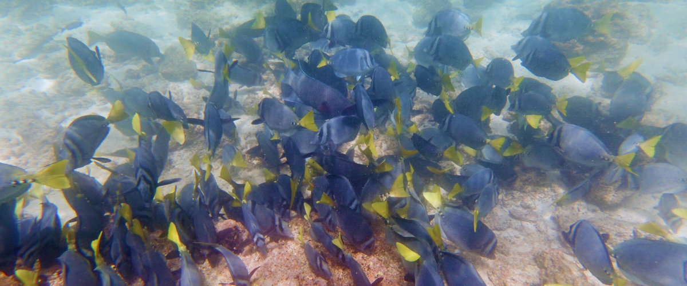
Snorkeling Experience: Following the hike, you can snorkel in shallow, sheltered water, where you'll encounter large schools of surgeonfish and parrotfish, along with reef sharks, rays, and a wide array of tropical fish.
Highlights: Galapagos land iguanas, Darwin finches, American flamingoes, white-cheeked pintails, Galapagos flycatchers, and herons.
As your journey through the Galapagos concludes, you will be transferred to the airport for your return flight to mainland Ecuador. Cherish these unique experiences and memories as you wave goodbye to this stunning ecological marvel. Safe travels!
Meals | B / L / D
Trail | 2,2 km / 1,4 mi

Glossary
Meals | Breakfast | B
 | Lunch | L
 | Dinner | D
Hiking Effort | Level 1 | Easy
 | Level 2 | Moderate
 | Level 3 | Hard

