Unvealing the Galapagos Southeast
Itinerary A / Southeast Cruise / 5 Days – 4 nights

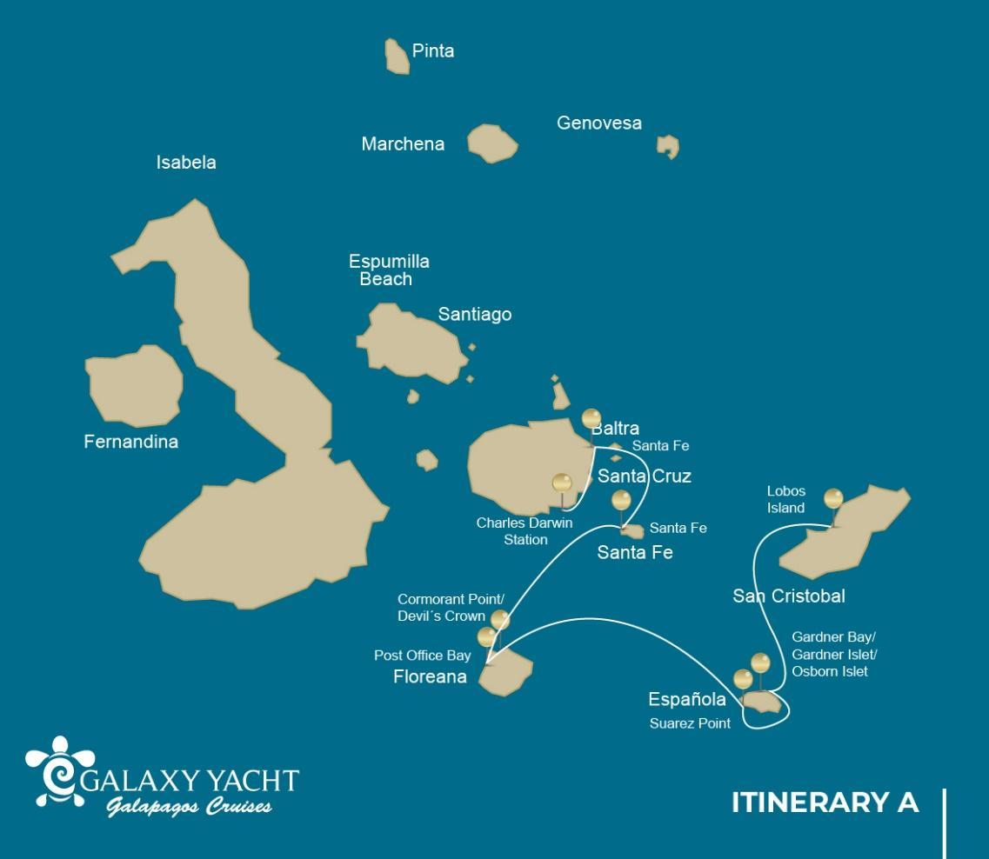
 |  |  |  | HIKING | SNORKEL | PANGA RIDE | PADDLE BOARD | KAYAK
5 DAYS "A" | TUESDAY | PM | San Cristobal: Lobos Island | • | • | •
 | WEDNESDAY | AM | Española: Gardner Bay /Gardner Islet/Osborn Islet | • | • | •
 |  | PM | Española: Suarez Point | •
 | THURSDAY | AM | Floreana: Post Office Bay | • | •
 |  | PM | Floreana: Cormorant Point/Devil's Crown | • | • | •
 | FRIDAY | AM | Santa Fe: Santa Fe | • | • | • | • | •
 |  | PM | Plazas Sur: South Plaza | •
 | SATURDAY | AM | Santa Cruz: Charles Darwin Station | •

Day 1 - Tuesday
AM: EMBARKATION TO THE GALAPAGOS ISLANDS - SAN CRISTOBAL AIRPORT
Unfurl the sails of adventure and embark on an unforgettable journey to the Galapagos Islands. You'll arrive at San Cristobal Airport, where a seasoned naturalist guide, the custodian of this ecological gem, will greet you. Feel the flutter of anticipation as your exploration of this astonishing world heritage site commences.
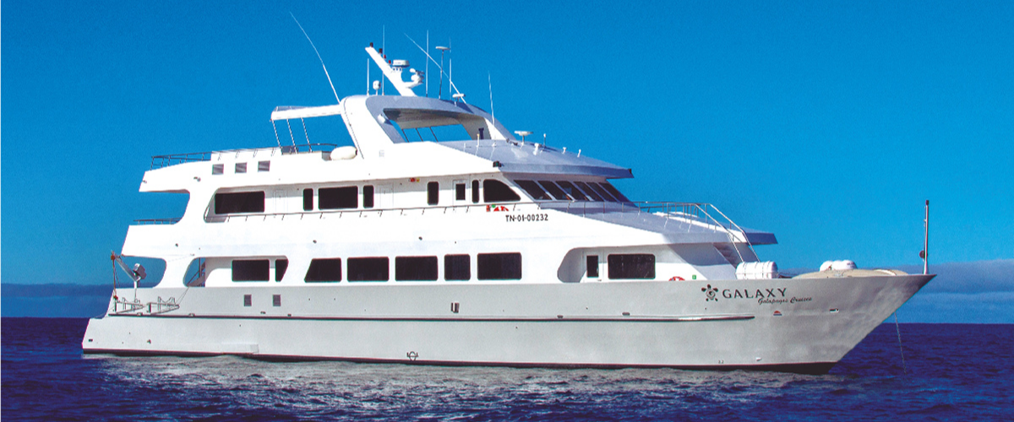
The Lobos Island itinerary has been changed since September 20, 2023, due to a contingency conservation plan for the species on this island. By the authorization of the Galapagos National Park, only a panga and snorkel tour around the island will be allowed.
This itinerary will return to normal once the Galapagos National Park deems it optimal for welcoming guests again.
PM: ENCOUNTERING WILDLIFE AT LOBOS ISLAND
Venture to Lobos Island, a tranquil islet secluded from San Cristobal by a slim channel. This nature's cradle, amidst a serene bay, is the playground for sea lion pups frolicking in tidal pools. The island might be modest in size, but it bursts with life, particularly with "lobos marinos" or sea lions. As you step ashore, welcoming committees of sea lions would greet you, only to be outraged by the male frigatebirds inland, presenting their inflamed red balloons amidst the verdant foliage. Stay vigilant for the blue-footed boobies nesting on the trails, ready to treat you to a display of their whimsical courtship dance.
Snorkeling Experience: Dive into an underwater ballet at this renowned snorkeling spot, sheltered by the calm waves. Playful sea lions would eagerly display their acrobatic prowess. In contrast, sea turtles and rays find solace resting on the sandy seabed, giving you a glimpse into the harmonious marine life that thrives beneath the surface.
Highlights: Galapagos sea lions, marine Iguanas, magnificent & great frigatebirds, blue-footed Boobies, and San Cristobal Lava Lizards.
Meals | L, D
Trail | 0,6 km / 0,4 mi
Level | 3
Activities | Dry landing and hiking

Day 2 – Wednesday
AM: A TROPICAL PARADISE - GARDNER BAY
Embrace the morning at Gardner Bay, a pristine piece of paradise in the Galapagos archipelago. Sugar-white coral sands merge with crystal-clear turquoise waters, creating a tropical oasis. Watch as the beach becomes a theatre, starring sun-basking sea lions in a playful performance. This idyllic setting invites you to stroll along the coast, immersing yourself in an enlightening experience as you delve into the biology of the endemic fauna - from the melodious Española mockingbird and the unique marine iguanas to the regal Galapagos hawks.
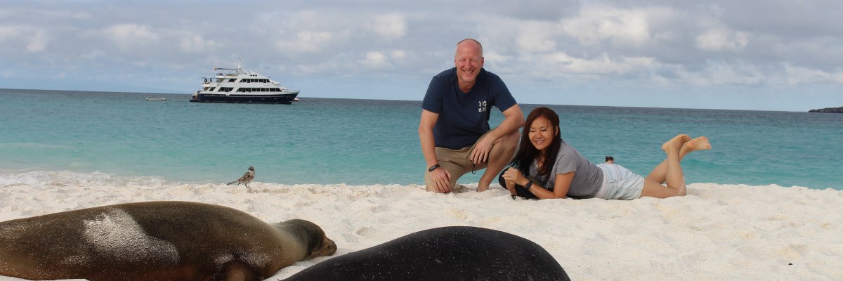
Snorkeling Experience: Submerge beneath the azure waves to witness a spectacular performance choreographed by marine life. Swim alongside playful sea lions, graceful reef sharks, and gliding rays. Discover an array of fish, including vivid Angelfish, charismatic Parrotfish, dynamic Damselfish, and the ever-busy Surgeonfish coloring the underwater landscape.
Highlights: Coral sand beach, sea lions, Galapagos hawks, Española mockingbirds, Darwin finches, marine iguanas.
Trail | 0,8 km / 0,5 mi
Level | 1
Activities | Wet landing and hiking

PM: A WALK-THROUGH NATURE'S GALLERY - SUAREZ POINT
The Suarez Point itinerary has been changed since September 20, 2023, due to a contingency conservation plan for the species on this island. By the authorization of the Galapagos National Park, only a 360-degree panga tour around the island will be allowed.
This itinerary will return to normal once the Galapagos National Park deems it optimal for welcoming guests again.
Transition into the afternoon with a thrilling adventure to Suarez Point. This rocky trail presents a natural gallery of the Galapagos islands, brimming with an awe-inspiring array of fauna. Upon landing, you'll be greeted by sea lions and marine iguanas, your first hosts in this nature carnival. As you venture further, you'll encounter a mosaic of seabird colonies - from the striking Nazca and blue-footed boobies to the elegant gulls and tropicbirds. The pinnacle of this journey brings you face-to-face with the waved albatross, the island's largest bird (present from April to January). This majestic creature, exclusive to Española, will captivate you with its powerful flight and intricate courtship display.
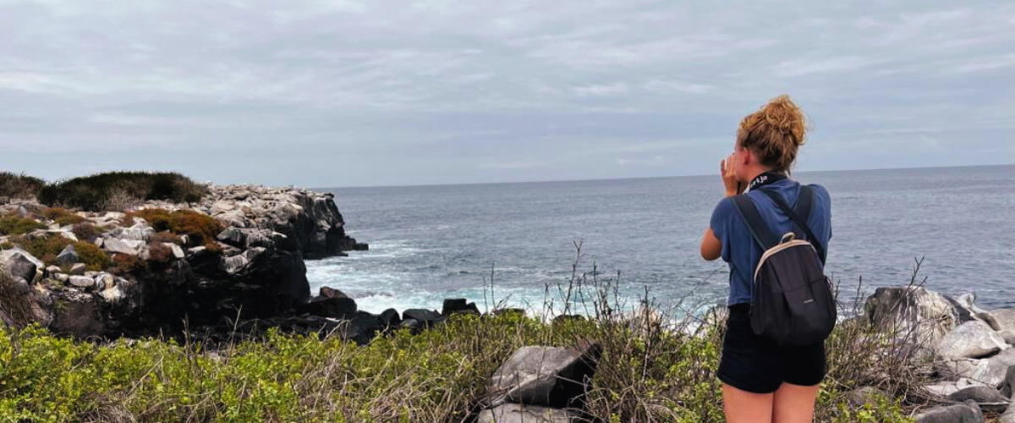
Highlights: Sea lions, Waved Albatross, Galapagos hawks, Española mockingbirds, Darwin finches, marine iguanas, Nazca & Blue-footed Boobies, Red-billed Tropicbirds, Swallow-tailed gulls, herons, lava lizards, herons.
Meals | Breakfast (B), Lunch (L), Dinner (D)
Trail | 1,7 km / 1,1 mi
Level | 3
Activities | Panga ride only.

Day 3 – Thursday
AM: MAIL FROM THE PAST - POST OFFICE BAY
Begin your day by stepping into the footprints of the past at Post Office Bay, located on the enigmatic Floreana Island. This locale is imbued with tales from the late 1920s and '30s involving German settlers, a baroness, unsolved mysteries, and captivating intrigue. The bay was a historic anchoring point for whalers, who journeyed to the highlands for freshwater and tortoises. A mail system over two centuries old was established as a hub for visiting vessels centered around a barrel near the beach. This system endures today, offering a unique opportunity to send postcards from this remote part of the world. Apart from its rich history, Post Office Bay presents natural attractions such as a scenic beach, a lava tunnel, and sea tours that can unveil sea lions, green sea turtles, shorebirds, small sharks, and, if luck permits, Galapagos penguins.
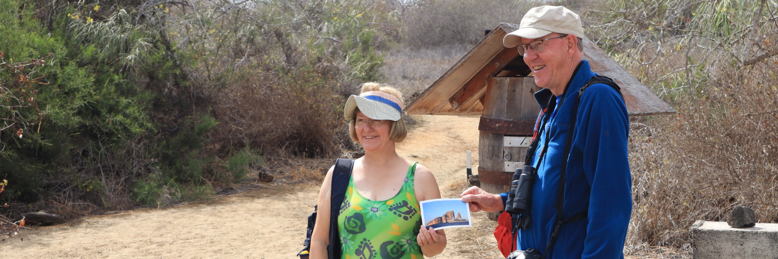
Snorkeling Experience: Delve beneath the waves right from the beach, opening up a mesmerizing world of sea turtles, rays, and a diverse plethora of fish. Keep your fingers crossed for a special appearance by the elusive Galapagos penguin.
Highlights: Sea Lions, sea turtles, finches, shorebirds, marine iguanas, and penguins.
Trail | 0,7 km / 0,4 mi
Level | 1
Activities | Wet landing and hiking

PM: THE WONDER OF NATURE - CORMORANT POINT / DEVIL'S CROWN
Shift your expedition northwards to Punta Cormorant, renowned for its expansive coastal lagoon teeming with American flamingos, white-cheeked pintails, black-necked stilts, and other shorebirds. This natural haven also features a pristine white sand beach, a crucial nesting ground for green sea turtles, and a newly established breeding ground for blue-footed boobies near the trail. Amidst this vibrant wildlife, also take the opportunity to admire the island's unique flora.
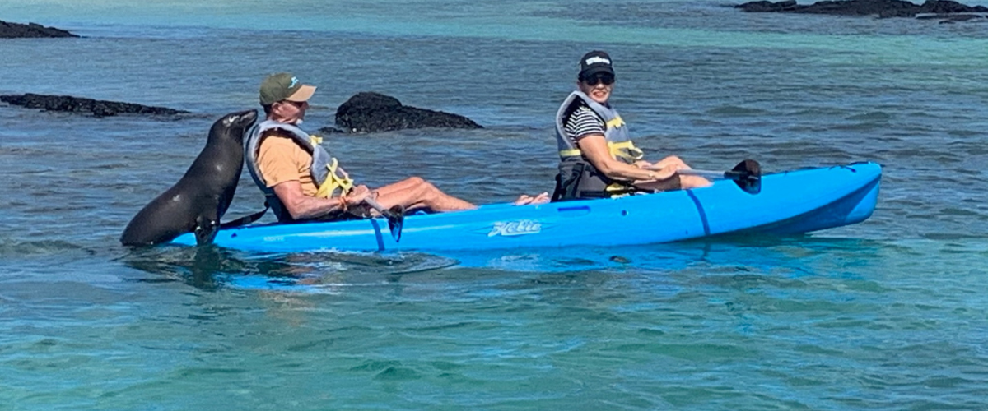
Snorkeling Experience: At Devil's Crown, an eroded little volcano adjacent to Floreana Island, dive into what many consider one of the best snorkeling sites in the entire Galapagos. The Crown's currents funnel plankton, attracting a spectacular congregation of marine life, including snapper, Creole fish, parrot fish, Angelfish, reef sharks, sea turtles, and rays.
Highlights: American flamingo, blue-footed booby, frigatebirds, tropicbirds, Galapagos shearwaters, sea lions, sea turtle nesting site, finches, shorebirds, coral-sand beach.

Meals | B / L / D
Trail | 1,6 km / 1 mi
Level | 1
Activities | Wet landing and hiking

Day 4 – Friday
AM: THE CONTRASTING BEAUTY OF SANTA FE
Lead in the day with the stark beauty of Santa Fe, where the towering figures of giant Prickly-pear cacti strikingly contrast the rugged landscape of lava rocks. Tucked within one of the Galapagos' most breathtaking bays, Santa Fe's turquoise waters, and white-sand beaches form an inviting residence for a sizable colony of sea lions you'll find lounging about. As you venture inland, remember to look down to spot the endemic Santa Fe land iguanas, but also glance upward to catch sight of the Galapagos hawks perched atop cacti, keeping a keen eye out for prey. You'll likely encounter Darwin finches, Galapagos doves, mockingbirds, and lively lava lizards along the trail.
Snorkeling Experience: After your exploratory hike, the sheltered bay offers you a choice: paddle through serene waters on a kayak or plunge beneath the surface to snorkel with playful sea lion pups and reef sharks. Also, keep an eye out for graceful sea turtles, gliding rays, and the swirling colors of tropical fish, including large schools of Surgeonfish and Parrotfish.
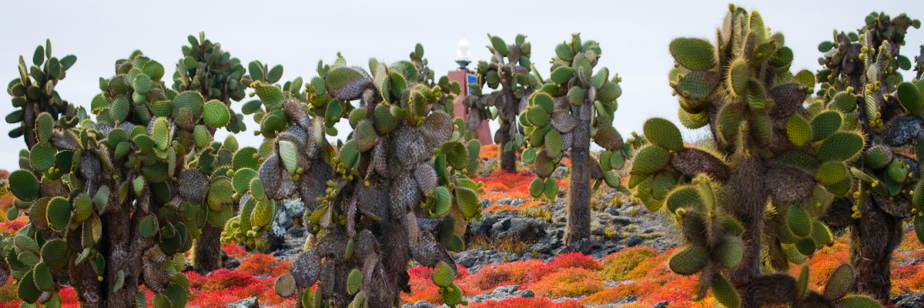
Highlights: Giant cactus, Santa Fe Bay, Galapagos sea lions, Santa Fe land iguanas, Galapagos hawks, Galapagos doves, reef sharks.
Trail | 0,8 km / 0,5 mi
Level | 1
Activities | Dry landing and hiking

PM: WILD WONDERLAND - SOUTH PLAZAS
Your afternoon destination is South Plazas, one of a twin pair of islands where the northern sibling is reserved exclusively for scientific research. Though petite in size, this islet brims with a fantastic array of wildlife. Upon landing, Galapagos land iguanas will welcome you from beneath prickly-pear cacti, eagerly awaiting their fruit. Sea lions populate the island in large numbers, allowing you to observe their fascinating social dynamics, from playful pups splashing in tide pools to formidable males protecting their territories. Your trail eventually leads you to a cliff, a vantage point to observe a myriad of seabirds, including frigatebirds, red-billed tropicbirds, boobies, swallow-tailed gulls, and pelicans. A verdant carpet of reddish succulent vegetation dotted with scattered cacti blankets the island, giving South Plazas a genuinely unique personality.
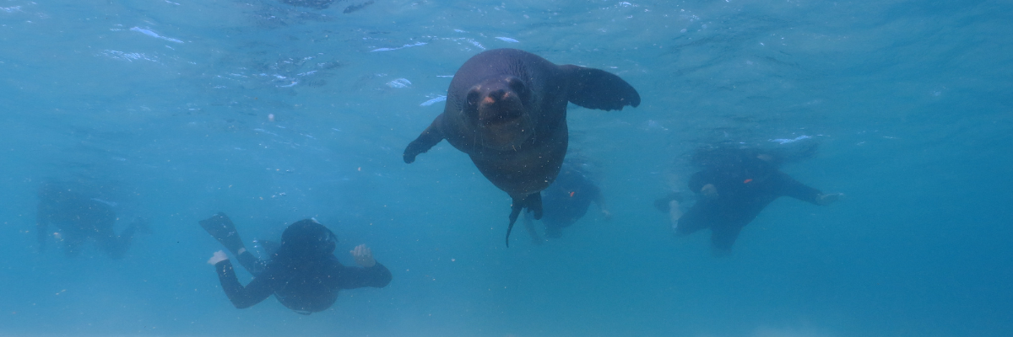
Highlights: Galapagos land iguanas, sea lions, tropicbirds, pelicans, boobies, Galapagos shearwaters, and swallow-tailed gulls.
Meals | B / L / D
Trail | 1,4 km / 0,8 mi
Level | 2
Activities | Dry landing and hiking

Day 5 – Saturday
AM: THE CRADLE OF CONSERVATION - CHARLES DARWIN STATION
Kickstart your day with a profound encounter at the Charles Darwin Station, a dedicated non-profit working hand-in-hand with the Galapagos National Park to safeguard the archipelago's unique biodiversity. This visit provides insights into the collaborative efforts of these institutions to shield native species and combat the invasive ones threatening the delicate balance of the Galapagos ecosystem. One of their emblematic endeavors includes the captive breeding giant tortoises, an integral part of the conservation strategy. Amidst the educational venture, enjoy the setting of an outdoor native dry forest adorned with towering cacti and a rich array of fascinating endemic flora. This is an ideal spot to discover various endemic Darwin finches, as well as vivacious flycatchers and melodious mockingbirds.
Highlights: Galapagos giant tortoise & land iguanas breeding program, Darwin finches, Galapagos mockingbirds, Galapagos flycatchers, yellow warblers.
Meals | B
Level | 1
Activities | Dry landing and hiking

Glossary

Meals | Breakfast | B
 | Lunch | L
 | Dinner | D
Hiking Effort | Level 1 | Easy
 | Level 2 | Moderate
 | Level 3 | Hard

