Diving into the Wildlife Wonders and Marine Magic of the Galapagos

5 DAYS / 4 NIGHTS - M/C ALYA*
* Temporary itinerary authorized by the Galapagos National Park Authority

 |  |  |  | HIKING | SNORKEL | PANGA RIDE | PADDLE BOARD | KAYAK
5 DAYS CRUISE "A" | THURSDAY | PM | Santa Cruz: Black Turtle Cove |  |  | •
 | FRIDAY | AM | Santa Cruz: Eden Islet | • | • | • |  | •
 |  | PM | Santa Cruz: Rabida | • | • | • | • | •
 | SATURDAY | AM | Santiago: Sullivan Bay | • | •
 |  | PM | Bartolome: Bartolome | • | • | •
 | SUNDAY | AM | Santiago: Chinese Hat | • | • | • | • | •
 |  | PM | Mosquera: Mosquera Islet | • | •
 | MONDAY | AM | Santa Cruz: Charles Darwin Station | •
 |  |  | Transfer out: Baltra Airport

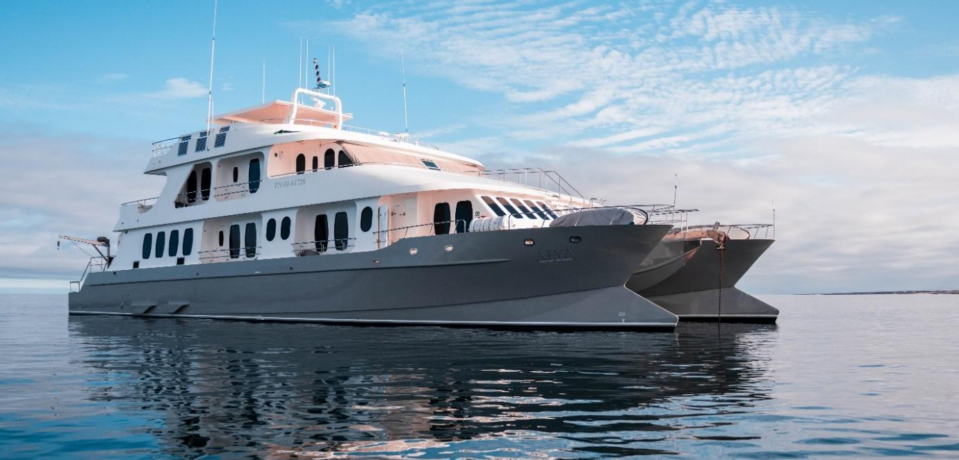

DAY 1

AM: ARRIVAL AT BALTRA AIRPORT
Your voyage to the captivating Galapagos Islands commences! Upon your arrival at Baltra Airport, you'll be greeted by our National Park-certified naturalist guide, ready to introduce you to the unique wonders of this pristine archipelago.

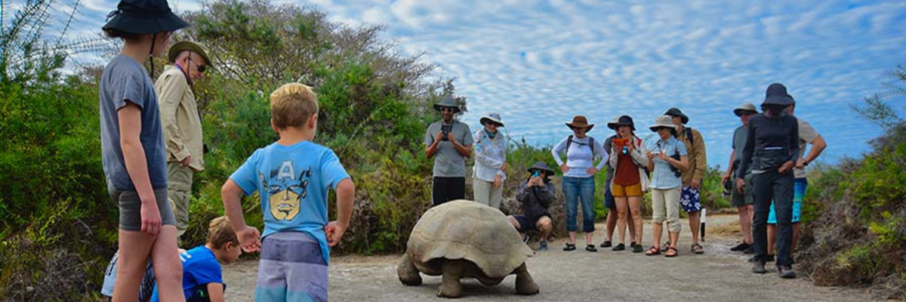

PM: BLACK TURTLE COVE
We dive into our Galapagos adventure at Black Turtle Cove, aptly named for the thriving "Tortugas negras" population or green sea turtles. We navigate this natural sanctuary on dinghies, cruising amidst serene mangrove forests and tranquil water channels. Expect sightings of reef sharks, diverse ray species, and a plethora of bird species, including herons, pelicans, and boobies. Remember, this magical cove is a significant breeding ground for turtles and a nursery for various shark species!

Highlights: White-tipped and black-tipped reef sharks, green sea turtles, rays, herons, blue-footed boobies, and mangroves.

Meals | L / D
Level | 1
Activities | Panga Ride

DAY 2
The itinerary of Genovesa, Darwin Bay, and El Barranco, established on this day, has been changed on September 20, 2023, by the Galapagos National Park Directorate (GNPD) due to a Contingency Plan for the Conservation of Species on this island. In its place, visits will be made to the neighboring islands based on the authorization of the Galapagos National Park.
This itinerary will return to normal when the GNPD considers it optimal for the reception of passengers again on Genovesa Island.

AM: EDEN ISLET
Eden Islet, true to its biblical name, evokes a paradisiacal oasis. Located near Santa Cruz Island, this tiny isle boasts heavenly beaches and crystal-clear waters reminiscent of the quintessential "deserted island." With a diameter of just 600 meters and its highest point reaching 77 meters, its small size is juxtaposed with its immense charm, home to nine turtle species.

Snorkeling Experience: Marvel at the sea stars that cover the ocean floor and the endemic fish, like the white-tailed damselfish, that call it home.

Highlights | Striped burrfish, reef sharks, blue-footed boobies, and Nazca boobies
Meals | Breakfast, Lunch and Dinner
Difficulty | Level 1
Activities | Snorkeling, Panga ride, Kayaking, and Hiking

PM: RABIDA
Rabida Island, recognized for its unique reddish lava rocks enriched with iron, has a distinct appearance in the Galapagos. The beach's unusual red hue reflects this characteristic, serving as a home for a small sea lion colony. If you're lucky, you'll discover a small saltwater lagoon inhabited by ducks, stilts, and flamingoes.

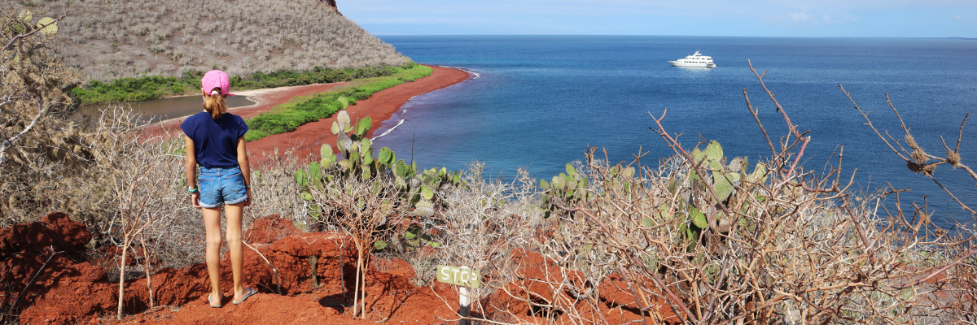

The trail invites you inland, offering spectacular beach and lagoon views. Keep an eye out for Darwin finches, flycatchers, and mockingbirds. Along the coastline cliffs, you can observe Nazca & blue-footed boobies, brown noddies, herons, and the two species of sea lions: the Galapagos and fur seals.

Snorkeling Experience: Embark on a snorkeling adventure from the beach and explore a protected rocky area brimming with fish, sea lions, and reef sharks. The vertical walls are a natural canvas showcasing an impressive variety of small invertebrates.

Highlights: Red-sand beach, Galapagos sea lions, Galapagos hawks, flycatchers, Darwin finches, Galapagos mockingbirds, ducks, flamingoes.

Meals | B / L / D
Trail | 2 km / 1,2 mi
Level | 1
Activities | Wet landing / Hiking, Snorkeling, Kayaking, and Panga Ride

DAY 3

AM: SULLIVAN BAY
Step back in time at Sullivan Bay, an open book to the volcanic birth of these islands. Traverse the well-preserved Pahoehoe lava field, studying its delicate, unique textures. The seemingly lifeless landscape gradually unveils a resilience of nature, with pioneer plants, lava lizards, and tiny birds emerging on careful observation. Keep your eyes on the shoreline for resident penguins, pelicans, and oystercatchers.

Snorkeling Experience: A dip in the water here starkly contrasts the barren land. The coral sand beach and the dinghy access point reveal a marine world with fish schools, Galapagos penguins, reef sharks, turtles, and rays.

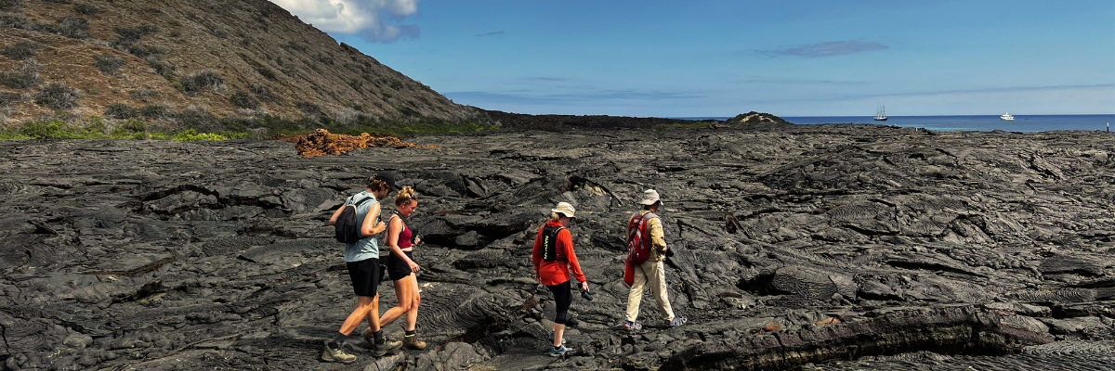

Highlights: Pahoehoe lava, Galapagos penguins, oystercatchers, Galapagos hawks.

Trail | 2,2 km / 1,4 mi
Level | 3
Activities | Dry landing and hiking

PM: BARTOLOME
Stand atop Bartolome Island for unparalleled views of the lunar-like landscape, punctuated by scattered volcanic cones, Pinnacle Rock, and the bay of Sullivan. Bartolome is a jewel in the Galapagos crown and home to a vibrant population of penguins.

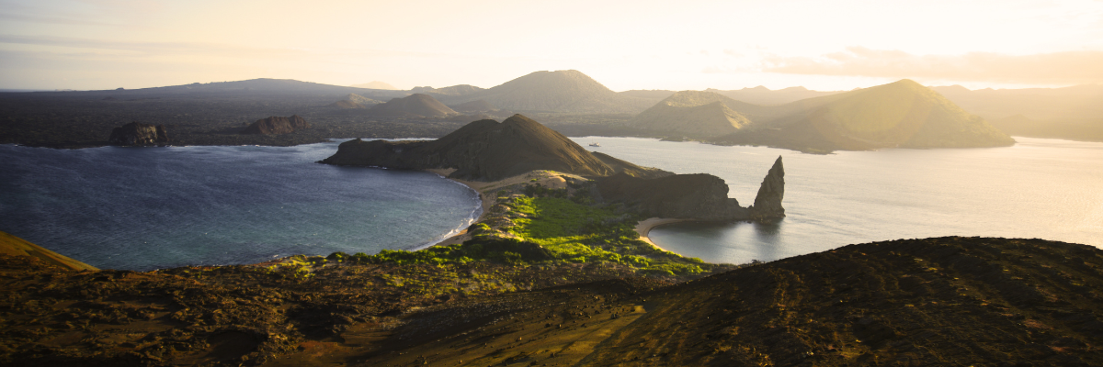

Snorkeling Experience: A swim or snorkel from the beach opens up an underwater playground renowned in the Galapagos. Penguins, a multitude of fish, colorful invertebrates, sea lions, turtles, rays, and reef sharks make this snorkeling experience unforgettable.

Highlights: Galapagos penguins, volcanic landscapes, Pinnacle rock, blue-footed boobies, herons, sea lions, sharks.

Meals | B / L / D
Trail | 1,5 km / 0,9 mi
Level | 2
Activities | Dry landing and hiking

DAY 4

AM: CHINESE HAT
Welcome to the perfectly symmetrical volcanic cone of Chinese Hat! Separated from Santiago by a slender channel, this idyllic islet is framed by turquoise waters, coral sand beaches, and dark lava rocks – an unexpected haven for penguins. A shore trail brings you up close to a small colony of sea lions.

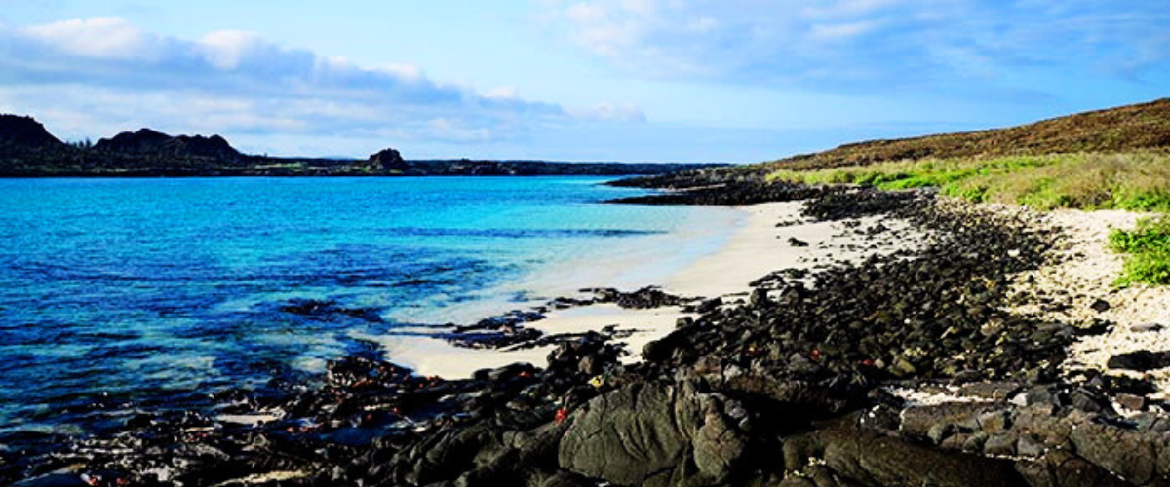

Snorkeling Experience: Experience a world of vividly colored fish, sleek reef sharks, and perhaps a swift penguin chasing after a school of anchovies. It's a mesmerizing underwater spectacle you want to take advantage of.

Highlights: Galapagos sea lions, Galapagos penguins, lava tubes, oystercatchers, Galapagos hawks.

Trail | 1,3 km / 0,8 mi
Level | 3
Activities | Wet landing and hiking

PM: MOSQUERA
Our afternoon destination is Mosquera, largely a barren sand bar with rocky outcrops and salt-resistant vegetation. Stroll along the beach, observing the playful antics of sea lion pups in the surf and tide pools. Keep an eye out for endemic lava gulls, often spotted in mid-flight hunting for their next meal.

Snorkeling Experience: Given favorable wave conditions, snorkel at the northern tip of the island or one of the smaller, sheltered beaches for another immersive marine encounter.

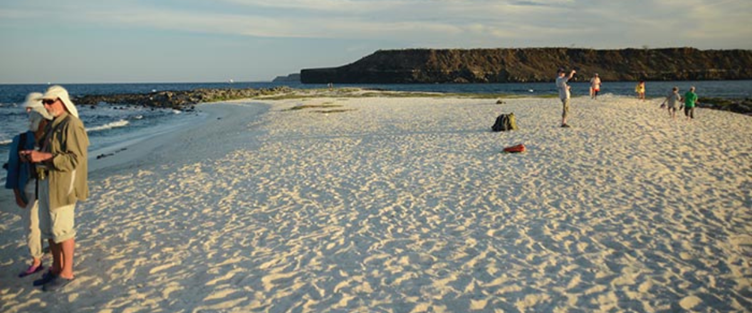

Highlights: Galapagos sea lions, lava gulls, oystercatchers, shorebirds,

Meals | B / L / D
Trail | sandy area of 0,6 km / 0,4mi
Level | 1
Activities | Wet landing and hiking

DAY 5

AM: CHARLES DARWIN STATION
Spend your morning at the renowned Charles Darwin Station. As a nonprofit organization working closely with the Galapagos National Park, the station is committed to the preservation and study of the archipelago's biodiversity. Discover the myriad initiatives underway to safeguard native species and combat invasive threats to the Galapagos ecosystem. This visit offers the unique opportunity to see giant tortoises bred in captivity.

Highlights: Galapagos giant tortoise & land iguanas breeding program, Darwin finches, Galapagos mockingbirds, Galapagos flycatchers, yellow warblers.

Following your visit to the Charles Darwin Station, you will be transferred to the airport for your flight back to mainland Ecuador, concluding your unforgettable Galapagos journey.

Meal | B
Trail | 2 km / 1,2 mi
Level | 1
Activities | Dry landing and hiking

Glossary

Meals | Breakfast | B
 | Lunch | L
 | Dinner | D
Hiking Effort | Level 1 | Easy
 | Level 2 | Moderate
 | Level 3 | Hard

